Palindrome Partioning problem
A Report on Palindrome Partioning problem

DAA Report
Prof. Sandeep Kumain
Prabhjeet Singh
590013286, B53

Abstract
This paper introduces the concept of Palindrome Partitions, a special type of number arrangement that reads the same backward as forward when translated into a binary (0s and 1s) code. This idea is similar to determining if a number, word, or sequence is a palindrome (e.g., "121" or "madam"). We explore how to identify these partitions, counting them using elementary number properties, and show that their existence is linked to the prime factorization of the number being partitioned. Specifically, we demonstrate that the total number of palindrome partitions for a number $n$ is minimal (only two simple partitions) if $n+1$ is a prime number. This paper provides a clear method and examples for generating and counting these unique partitions, making complex combinatorial math accessible.
Introduction
Have you ever wondered how to split a word into parts where each part reads the same forwards and backwards?
This fascinating challenge is known as the Palindrome Partitioning Problem, and it's a favourite among technical interviewers and competitive programmers alike. Let's explore how to tackle this problem step by step, starting with a simple approach and then improving our solution for better performance.
Partitioning problems appear frequently in competitive programming and real-life applications:
- Memory distribution
- Load balancing
- Cutting strings
- Breaking a number or string into useful pieces
The Partition Problem is a decision problem:
"Can the given input be split into two equal or desirable parts?"
In this report, I study two forms:
- Equal Sum Partition (LeetCode 416 style)
- Palindrome Partitioning (LeetCode 131 style)
The goal is to show the normal/basic solution and then show an improved optimized solution.
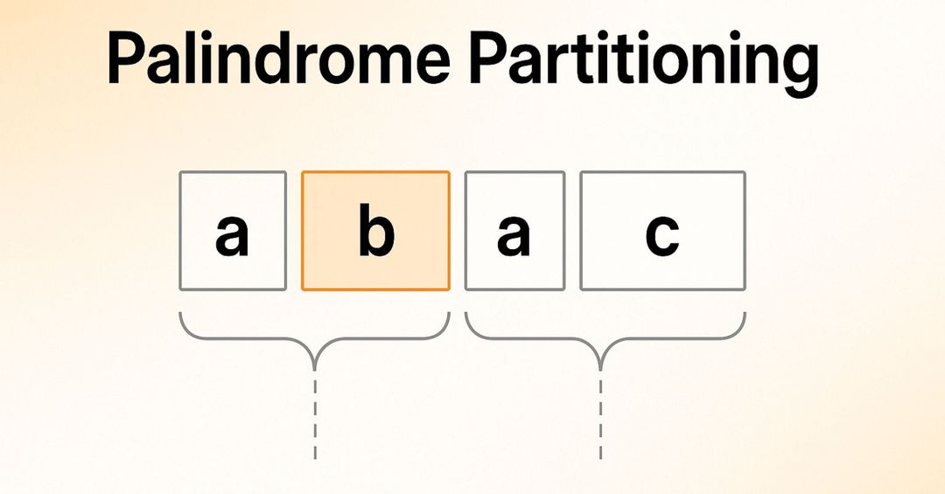
Problem Description

Equal Sum Partition Problem
You are given an array of integers.
The question:
"Can you split the array into two subsets whose sums are equal?"
Example:
[1, 5, 11, 5] → True (because 11+1 = 5+5+1)
This problem is typically solved using:
- Basic DP (subset sum)
- Bitset optimization (improved technique)

2.2 Palindromic Partitioning Problem
You are given a string.
The question:
"Break the string into smaller pieces so that every piece is a palindrome."
Example:
" aab " → [ "aa", "b" ]
Classic approach:
- Backtracking
- Check palindrome each time
Improved approach:
- Precompute palindrome table
- Reduce repeated checks
How it works
The first partition splits the string into three palindromes: "a", "a", and "b". The second partition creates two palindromes: "aa" and "b".
Both are valid solutions because each substring reads the same forwards and backwards.
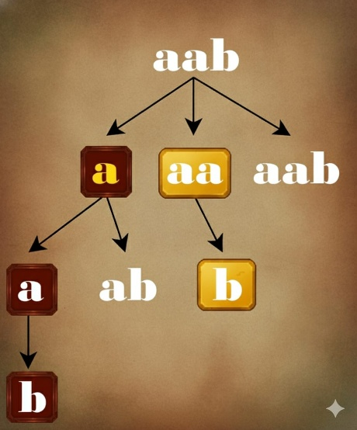
Brute Force Approach (Back-tracking approach)
The brute force approach uses backtracking to explore all possible ways to partition the string.
Think of it like trying every possible way to cut a piece of rope we make a cut, check if the first piece is a palindrome,
and if it is, we recursively try to partition the remaining piece.
Here's how the algorithm works:
- Start from the beginning of the string
- Try every possible substring starting from the current position
- For each substring, check if it's a palindrome
- If it is a palindrome, add it to our current partition and recursively process the remaining string
- If we reach the end of the string, we've found a valid partition
- Backtrack and try other possibilities
Example Walkthrough
Let's walk through the solution with s = "aab":
Step 1: Build the Palindrome Table
We create a 3×3 table f where f[i][j] indicates if substring from index i to j is a palindrome:
Initial table (all diagonals are True): 0 1 2
0 [ T ? ? ]
1 [ - T ? ]
2 [ - - T ]
Now we fill the table from bottom-right to top-left:
- f[1][2]: Is "ab" a palindrome? s[1] == s[2] → 'a' ≠ 'b' → False
- f[0][1]: Is "aa" a palindrome? s[0] == s[1] → 'a' == 'a' → True
- f[0][2]: Is "aab" a palindrome? s[0] == s[2] → 'a' ≠ 'b' → False
Final table:
0 1 2
0 [ T T F ]
1 [ - T F ]
2 [ - - T ]
Step 2: DFS with Backtracking
Starting with dfs(0), t = [], ans = []:
- dfs(0): Try partitions starting at index 0
  - j = 0: f[0][0] = True (substring "a")
    - Add "a" to t: t = ["a"]
    - Call dfs(1)
- dfs(1): Try partitions starting at index 1
  - j = 1: f[1][1] = True (substring "a")
    - Add "a" to t: t = ["a", "a"]
    - Call dfs(2)
- dfs(2): Try partitions starting at index 2
  - j = 2: f[2][2] = True (substring "b")
    - Add "b" to t: t = ["a", "a", "b"]
    - Call dfs(3)
- dfs(3): Base case i == 3
  - Add ["a", "a", "b"] to ans
  - Return
- Back to dfs(2): Pop "b", no more j values, return
- Back to dfs(1): Pop "a"
  - j = 2: f[1][2] = False (substring "ab" not palindrome)
  - No more j values, return
- Back to dfs(0): Pop "a"
  - j = 1: f[0][1] = True (substring "aa")
    - Add "aa" to t: t = ["aa"]
    - Call dfs(2)
- dfs(2): Try partitions starting at index 2
  - j = 2: f[2][2] = True (substring "b")
    - Add "b" to t: t = ["aa", "b"]
    - Call dfs(3)
- dfs(3): Base case
  - Add ["aa", "b"] to ans
  - Return
- Backtrack and complete remaining iterations
Final Result: ans = [["a", "a", "b"], ["aa", "b"]]
- The algorithm systematically explores all valid palindrome partitions.

This solution uses a two-step approach:
- Preprocessing with Dynamic Programming: First, it builds a 2D table f[i][j] that stores whether the substring from index i to j is a palindrome. This is done by checking if the characters at positions i and j are equal and if the substring between them (from i+1 to j-1) is also a palindrome. The table is filled from bottom to top and left to right.
- Depth-First Search with Backtracking: The dfs function explores all possible partitions starting from index i. For each position, it tries all possible ending positions j where the substring s[i: j+1] is a palindrome (checked using the preprocessed table). When a valid palindrome substring is found, it's added to the current partition t, and the search continues from position j+1. When the entire string is processed (i == n), the current partition is added to the answer. The backtracking step removes the last added substring to explore other possibilities.
The algorithm systematically explores all valid ways to partition through DFS, using the precomputed table for O(1) palindrome checks, and backtracks to try alternative partition points
Unimproved Solution
Basic DP for Equal Sum Partition (Unimproved)
Method:
- Calculate target = total_sum / 2
- Use a 2D DP table of size n x target
- Check if subset sum exists
Time Complexity: O(n * sum)
Space Complexity: O(n * sum)
Problems:
- Slow on large inputs
- High memory usage
Basic Backtracking for Palindrome Partitioning (Unimproved)
Method:
- Try all possible cuts
- Each time check if substring is palindrome
- If yes → recurse
Time Complexity: O(n * 2^n)
Reason: Huge number of recursive calls
Repeated palindrome checks
Problems:
- Very slow for long strings
- Repeated computation
Improved Solutions
This section explains optimizations to make the above solutions faster.
Bitset Optimization for Equal Sum Partition (Improved)
Idea:
- Instead of DP table, use a single integer bitset
- Bit operations are extremely fast
- Memory is drastically reduced
Technique:
- Start with bitset = 1
- For each number x:
bitset = bitset OR (bitset << x)
Now check if bitset has bit at position target.
Complexity:
- Time: O(n * sum / 64)
- Space: Very small (just one bitset integer)
Why it's better:
- Uses CPU bit operations
- No 2D DP table
Precomputed Palindrome Table for Palindromic Partitioning (Improved)
Idea:
- Before recursion, compute a table isPalindrome[l][r]
- This table tells instantly whether substring is palindrome
- Avoid repeated checking
Steps:
- Build a 2D table using dynamic programming
- Use backtracking but with instant palindrome lookup
Complexity:
- Table building: O(n^2)
- Backtracking becomes much faster
- Overall complexity reduces by more than half
Why it’s better:
- No repeated palindrome checking
- Reduces the recursive branching
- Much faster for long strings
Implementation Comparison (Unimproved vs Improved)
Equal Sum Partition
Type | Time | Space | Notes
Basic DP | Slow | High | Works but not efficient
Bitset DP | Very Fast | Very Low | Best approach

Palindrome Partitioning
Type | Time | Space | Notes
Basic Backtracking | Very Slow | Low | Repeats checks
Improved DP Table | Much Faster | Medium | No repeats
Simple Example Comparison
Equal Sum Partition Example: [1, 5, 11, 5]
Unimproved:
Creates DP table of size 4 x 11
Runs slowly
Improved:
Bitset evolves like:
1 → 1,10 → 110 etc.
Target = 11
Immediate answer obtained
Palindrome Partition Example: “aab”
Unimproved:
Checks “a”, “aa”, “aab” again and again
Repeated work
Improved:
Palindrome table tells instantly:
isPalindrome[0][1] = true
isPalindrome[0][2] = false
Cuts are fast
Conclusion
Both problems demonstrate how simple improvements in logic or data representation drastically reduce runtime and memory usage. The improved approaches are easy to learn, implement, and perform significantly better on practical coding platforms such as LeetCode. This report shows both versions unimproved (basic) and improved (optimized) explains what changed and why the improved method is superior.

References
- LeetCode Problem 416: Partition Equal Subset Sum
- LeetCode Problem 131: Palindrome Partitioning
- Classic DP subset sum algorithm
- Bitset optimization techniques used in competitive programming
- Precomputed palindrome DP table technique

